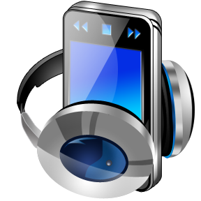Dear Parents & Guardians,

The media center has MP3 players for use with audio books. These items are available to support students for whom reading is a challenge. Research shows that students who listen to audio books while following along with the printed text can increase their level of reading comprehension.

Participating students will have the opportunity to check out an MP3 player with the selected novel loaded onto it. The loan period will be 3 weeks unless it is a class novel. Under those circumstances the circulation period will be the length of time it takes the class to complete their study of the novel. Students will need their own earbuds or headphones. They can purchase a set from the media center for a $1.00.

Students may use the MP3 players during school hours when in their special education classes or resource room. They are not to use them in their general education classes unless permission is granted by the teacher. The MP3 players are not to be used for personal files or music files. Students violating these policies will lose their MP3 player privileges for the remainder of the school year.

C:\Users\etrowbridge\AppData\Local\Microsoft\Windows\Temporary Internet Files\Content.IE5\LDBNCVNC\MC900396954[1].wmfThis is an optional program that requires parental permission for participation. The replacement cost of an MP3 player is $30.00. If you are interested in making this opportunity available for your son or daughter, both you and your child must sign and return the attached permission form.

Sincerely,

Erica Trowbridge

Library Media Specialist