How to Schedule Computer Labs & Chrome Carts
- Open Google Calendar

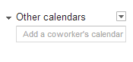
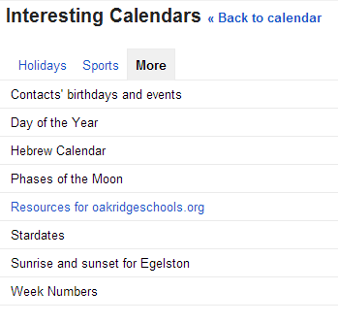
- Click on the drop down box next to

- Click “Browse Interesting Calendars”
- Click “More”

- Click on “Resources for oakridgeschools.org”

- Find the labs and Chrome Carts and click to “Subscribe” over to the right. The calendars you are already subscribed to will say “Unsubscribe”.
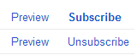

- Click “Back to calendar” at the top of the page.
- To schedule a lab, you need to click the button at the top left of the calendar.

- Type your last name where it says “Untitled Event”.

- Click where the date is and change it to the date you are trying to schedule. Do NOT put an end date. This will change automatically.
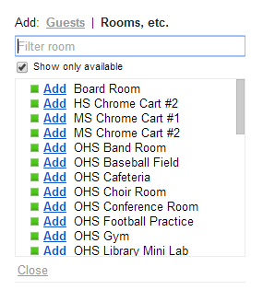
- Put a starting time and an ending time using 15 minute increments.

- Over to the right side of the screen where it says “Guests” and “Rooms”…click “Rooms”.

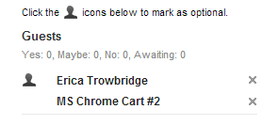
- Click the Add next to the lab you are trying to schedule. The room will show up under your name.

- Then click “Save”.

- Look on the calendar to make sure your time showed up.

*To Schedule Repeat times…
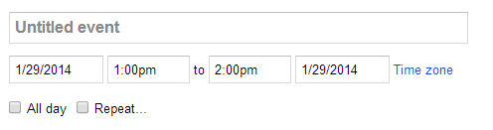
- Make sure that ALL the time slots are available before you begin! If there is another person scheduled in even just one of these times on another day, your times will not go through.

- Go through Steps 8-13 above.

- Click “Repeat” under the date and time.

- Click the drop down arrow where it says “Weekly” and choose your option.
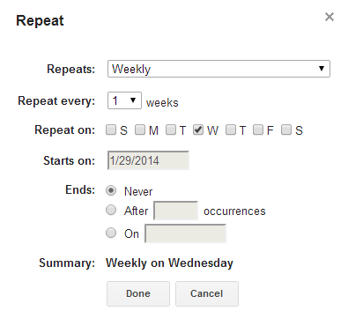
- The starting date should automatically appear. Click the Circle next to “Ends” and choose your ending date.

- Then click “Done”.
- Click “Save”.

- Check to make sure your times are on the lab calendar. If they are shaded, then it did not go through and you need to contact Erica.
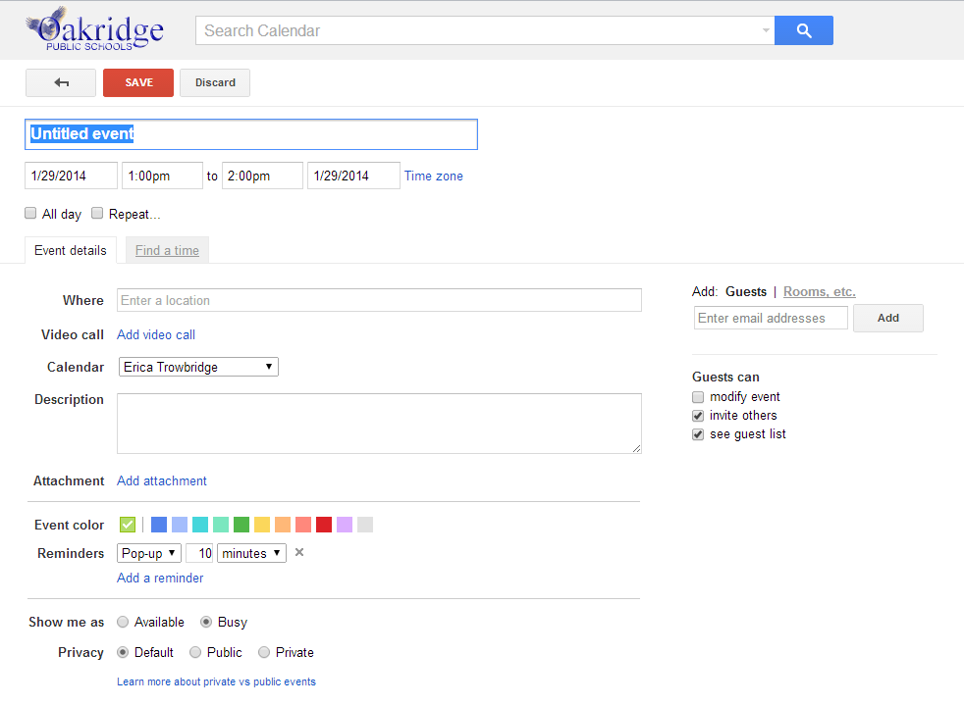
You can invite others to your events. Start typing their name in the box if they are a part of Oakridge. If they are not a part of Oakridge, you can add them to your event using their email address. Then click “Add”.
You don’t need to put anything here. This will be automatically filled out when you choose your room.
Schedule in 15 minute increments.
Click “Rooms” to choose a lab.
Your Last name here.

